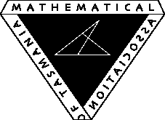
Mathematical Association of Tasmania 2016 Conference
Primed for Maths
Key note speakers Amie Albrecht and Lily Serna

FRIDAY 13th May 5pm-6pm
SATURDAY 14th May 9am – 3.30pm

at Burnie High School, Burnie

Trade Exhibitor Invitation

We would like to invite you to promote your products and services at this year’s MAT Annual Conference. Access to set up exhibitions will be available from 4.00pm until 5.00pm on the Friday and from 8.30am – 9.30am on the Saturday. Please follow the link below to register for this event.

We would be happy to include any advertising items in our conference satchels. However, this will need to be pre-arranged and items received by Friday, May the 6th, 2016. These items may include pens, notepads, pamphlets or any other relevant material.

We are also seeking donations for lucky door prizes and as gifts for presenters. If you would be able to assist in any form with this, please contact Brett Riley. The donated products for prizes will be recognised in the conference proceedings. We are expecting 175 attendees.

Thank you for your time
Brett Riley and Louise Hodgson

Brett.riley@education.tas.gov.au
Mobile: 0447395207

Lmhod1@student.monash.edu
Mobile: 0419139927

